TECHNICAL UNIVERSITY - SOFIA
FACULTY OF COMPUTER SYSTEMS AND TECHNOLOGIES

BACHELOR THESIS ON TOPIC OF
DEVELOPING WEB SYSTEM USING CONVOLUTIONAL NEURAL NETWORK FOR CLASSIFICATION OF PLANT DISEASES

KIRIL SHIYAN
2026
FACULTY NUMBER 273222008

2026
TABLE OF CONTENTS

Ⅰ. INTRODUCTION 5
Ⅱ. PROBLEM DOMAIN AND LITERATURE REVIEW 7
HISTORIC OVERVIEW OF NEURAL NETWORKS 7
THEORY BEHIND NEURAL NETWORKS 9
GENERAL ARCHITECTURE OF CNN 9
TRANSFER LEARNING 11
PLANT DISEASE DATASETS 13
PLANTVILLAGE 13
PLANTDOC 14
EXISTING PLANT DISEASE CLASSIFICATION MODELS 15
MOHANTY ET AL. [6] 15
SALMAN ET AL. [1] 16
Ⅲ. SYSTEM DESIGN 18
GOALS AND OBJECTIVES 18
WEB MODULE 19
SYSTEM FUNCTIONS 19
SYNTHESIS OF STRUCTURE - FRONTEND 20
SYNTHESIS OF STRUCTURE - BACKEND 22
SYNTHESIS OF STRUCTURE- ENGINE 24
MODEL TRAINING 26
ASSESSMENT OF DATASETS 26
MODEL SELECTION 27
FINE-TUNING STRATEGY 28
Ⅳ. SOFTWARE IMPLEMENTATION 29
FRONTEND 29
PROJECT STRUCTURE 29
BACKEND 33
PLANTDISEASEDETECTION.WEBAPI.API 33
PLANTDISEASEDETECTION.WEBAPI.ENGINE.CONTRACTS 34
PLANTDISEASEDETECTION.WEBAPI.ENGINE.RUST 34
ENGINE 36
BUILD 36
MODULE 36
TRAINING 37
CONFIGURATION 38
DATASET PREPARATION 38
MODEL 38
TRAINING LOOP 39
EXPERIMENT TRACKING 39
MODEL EXPORT 39
MODEL 39
BROAD SWEEP 39
FINAL MODEL 40
V. USER GUIDE 42
RUNNING PROJECT 42
USING WEB APPLICATION 43
CONCLUSION 45
SOURCES 47
APPENDIX 48

Ⅰ. INTRODUCTION
Global food security faces mounting pressure from a convergence of interconnected threats. UN’s 2024 World Population Prospects report projects that world's population is expected to reach just under 10 billion people by 2050 [7], demanding an increase in food production of up to 56% [9] . Yet plant diseases and pests already cost the global economy an estimated USD 220 billion annually, accounting for the loss of 10–16% of all crop production with additional 8 to 12% of post-harvest losses [8]. These losses are not static - climate change is actively worsening them. Studies project losses that can reach 50% by 2050 [8]. Rising temperatures shorten pathogen incubation periods, elevated carbon dioxide levels enhances the severity of diseases such as powdery mildew and wheat head blight, and increased humidity promotes fungal spore germination and infection rates [10]. As a result, pathogens are expanding into regions previously free of disease, and any potential yield gains over the next five decades are projected to be offset by climate-mediated increases in disease pressure [10]. The situation is further aggravated by globalization and international trade, which accelerate the movement of pathogens across continents, exposing crops to diseases against which they have no evolved resistance[10].
Traditional approaches to plant disease management, such as manual inspection by agronomists, chemical fungicides, and disease-resistant cultivars, are increasingly inadequate. Manual diagnosis is slow, costly, labor-intensive, and highly dependent on the expertise of the individual [6]. Chemical controls have reached a plateau of effectiveness as pathogens develop resistance, and their continued use raises serious concerns for soil health, biodiversity, and human health [10]. What is urgently needed, therefore, is a scalable, accurate, and cost-effective system capable of detecting plant disease early, before visible symptoms become severe and before large portions of a crop are lost.
Recent advances in deep learning, particularly Convolutional Neural Networks (CNNs), have opened a promising path toward automated, image-based plant disease recognition [10]. CNNs are capable of learning complex visual features directly from leaf images without the need for manual feature engineering, and when combined with transfer learning from large pretrained models, they can achieve high classification accuracy even on relatively small domain-specific datasets. Studies have demonstrated that CNN-based models trained on the PlantVillage dataset, a publicly available collection of over 54,000 annotated plant leaf images spanning 14 crop species and 26 diseases [11], can accurately identify plant diseases, with some architectures achieving accuracies above 99% on theoretical data [11]. Among these, MobileNet has emerged as a particularly strong candidate, offering state-of-the-art accuracy on ImageNet1K with significantly lower computational cost than other CNN architectures [23], making it well-suited for deployment in resource-constrained agricultural settings.
The goal of this work is to develop and evaluate a CNN-based plant disease recognition system using transfer learning with MobileNet using PlantVillage dataset for training and PlantDoc for validation. By enabling rapid, automated, and accurate identification of plant diseases from leaf photographs, such a system could serve as a practical tool for early intervention by helping farmers, agronomists, and agricultural organizations respond to outbreaks before they escalate, reduce reliance on broad-spectrum chemical treatments, and contribute to more resilient and sustainable food production in the face of a changing climate. This work aims to produce end-to-end web system that enables easy and free access to disease classification model.

Ⅱ. PROBLEM DOMAIN AND LITERATURE REVIEW

HISTORIC OVERVIEW OF NEURAL NETWORKS
The origins of artificial neural networks can be traced back to the mid-twentieth century, when researchers first attempted to model the computational behaviour of biological neurons mathematically. The foundational concept was introduced by McCulloch and Pitts [12], who proposed a simplified mathematical model of a neuron as a binary threshold unit - the first formal description of a computational element inspired by the human brain. This was followed by Rosenblatt's Perceptron [13], a single-layer learning algorithm capable of binary classification, which demonstrated for the first time that a machine could learn from data by adjusting its weights through experience. Despite initial enthusiasm, the limitations of single-layer architectures were formally exposed by Minsky and Papert [14], who proved that the Perceptron could not solve non-linearly separable problems such as the XOR function, triggering what became known as the first "AI winter" - a prolonged period of reduced interest and funding in neural network research.
The field was revitalized in 1986 when Rumelhart, Hinton, and Williams published their landmark work on the backpropagation algorithm, which provided an efficient method for training multi-layer networks by propagating error gradients backwards through the network. This enabled, for the first time, the training of deep architectures with hidden layers by laying the theoretical groundwork for all modern neural networks. Building directly on this work, LeCun et al. [16] applied backpropagation to train the first convolutional neural network at AT&T Bell Labs, producing a model capable of recognizing handwritten zip codes from the US Postal Service. His network introduced the key principle of local receptive fields and shared weights, allowing the model to detect spatial patterns regardless of their position in the image. This was achieved by utilizing a novel layers that applied mathematical operation of convolution to input matrix (image in this case). The architecture was refined over the following decade, culminating in LeNet-5 [15], a seven-layer CNN comprising convolutional layers, average pooling layers, and fully connected layers, which achieved 99.05% accuracy on the MNIST handwritten digit benchmark and formally established the architectural template that modern CNNs still follow today.
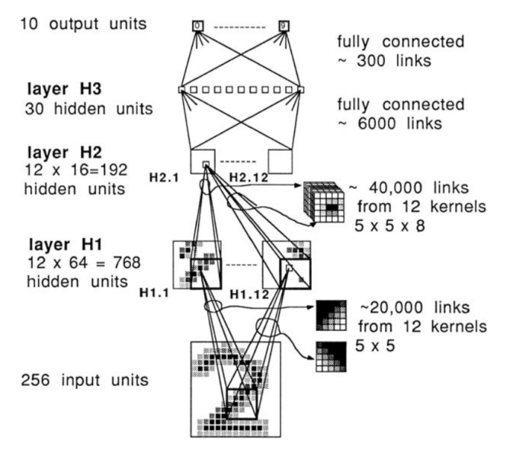
Figure 1.1 - First CNN developed by LeCun et al. [16]
Despite these achievements, CNNs remained computationally impractical for large-scale problems throughout the 1990s and early 2000s, constrained by limited processing power and insufficient training data. The landscape changed dramatically in 2012, when Krizhevsky, Sutskever, and Hinton introduced AlexNet, a deep CNN with five convolutional layers, three fully connected layers, and approximately 60 million parameters trained on 1.2 million images from the ImageNet dataset across 1,000 object categories. AlexNet achieved a top-5 error rate of 17.0% on the ILSVRC-2012 benchmark, outperforming the second-best entry by more than 10 percentage points and triggering a paradigm shift across the entire computer vision community. Critically, AlexNet demonstrated the practical utility of three techniques that are now standard: the ReLU activation function, which accelerated training by avoiding the vanishing gradient problem associated with sigmoid activations; dropout regularization, which reduced overfitting by randomly deactivating neurons during training; and GPU-accelerated computation, which made training on large datasets feasible for the first time.
The years following AlexNet saw rapid architectural innovation. Simonyan and Zisserman [17] introduced VGGNet, which demonstrated that network depth was a critical factor in classification performance - achieving state-of-the-art results on ILSVRC-2014 by stacking up to 19 layers of small 3×3 convolutional filters. VGG16 and VGG19 became widely adopted as transfer learning backbones due to their simplicity and strong representational power.

CNNs have found widespread adoption in domains where processing power is amongst the primary constraints. MobileNetV1 [22] was one of the first architectures explicitly optimized for edge computing environments, introducing depthwise separable convolutions as a drop-in replacement for standard convolutions, dramatically reducing both parameter count and computational cost with only a modest impact on accuracy. Its smallest quantized variant, MobileNetV1 0.25 128, which combines a width multiplier of 0.25 with a reduced input resolution of 128×128 pixels, contains just 0.8 million parameters, a footprint small enough to enable inference without GPU acceleration, even on severely resource-constrained devices such as embedded microcontrollers.

THEORY BEHIND NEURAL NETWORKS

GENERAL ARCHITECTURE OF CNN
While CNNs can utilize a wide variety of layer types in their construction, certain fundamental building blocks appear consistently across the most successful and widely adopted architectures. To understand these core components and their roles, it is necessary to examine them in the context of a concrete example, in particular, aforementioned VGGNet architecture (Fig. 1.2) [17], which, due to its straightforward and systematic design, serves as one of the most commonly referenced models for illustrating the structure of a deep convolutional network.
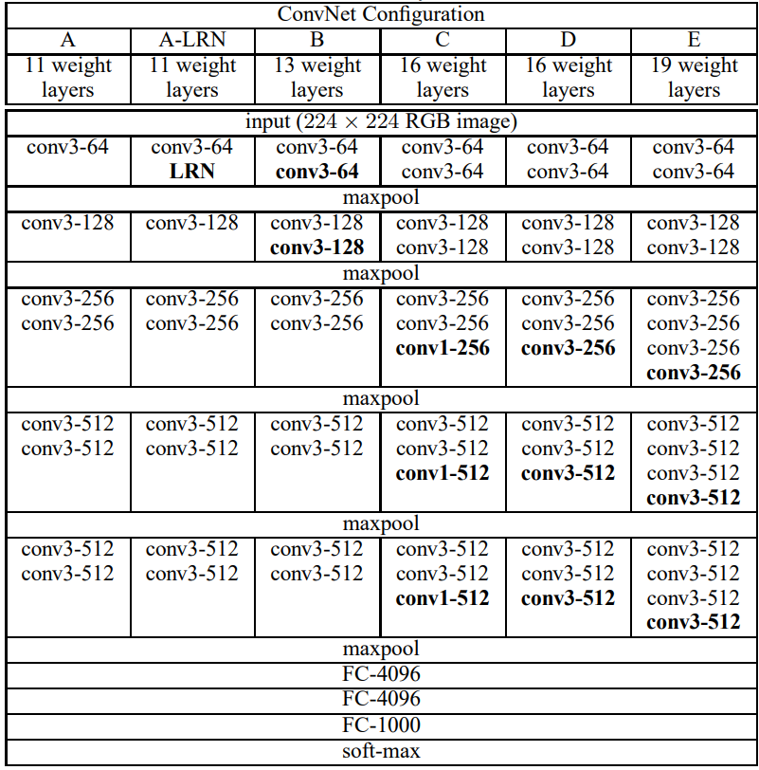
Figure 1.2 - Architecture of different versions of VGGNet CNNs.
To showcase the most common layer types found in CNN architectures, let us examine the most popular model from VGGNet family, namely VGG16, in detail. As shown in Fig. 1.2 under column C, VGG16 is a deep neural network comprising 23 layers organized into 6 distinct blocks. The first five blocks are convolutional blocks, each terminated by a max-pooling layer responsible for spatial downsampling. The final block is the classifier head, consisting of three fully connected (FC) layers, two with 4,096 units each, followed by a 1,000-unit output layer with a softmax activation. The output dimensionality of 1,000 corresponds directly to the number of classes in the ImageNet-1K dataset, on which VGG16 was originally trained. Convolutional layers serve as the primary computational workhorse of the entire architecture. Unlike fully connected layers, which process the entire input globally by connecting every input neuron to every output neuron, convolutional layers operate locally by processing only a small spatial window of M × N pixels at a time, defined by the kernel size. This operation, known as point-wise convolution, is expressed as:
(1.1)
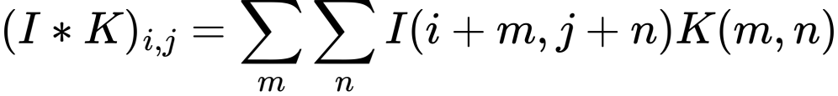
where I denotes the input image on which the convolution is performed, K denotes the learnable kernel, (i, j) represents the 2D coordinates of the output pixel, and (m, n) represents the 2D coordinates within the kernel window.
The kernel is "slid" systematically across the input with a defined stride, computing a weighted sum at each position and producing a feature map as output. Because each neuron in a convolutional layer responds only to its local receptive field rather than the entire image, the model is constrained to learn local spatial patterns, such as edges, textures and shapes, independent of their absolute position within the image. This property, known as translational invariance, represents a fundamental advantage over earlier perceptron-based models, which had no such spatial awareness.
Finally, the fully connected layers at the end of the network consume the flattened output of all preceding convolutional blocks simultaneously, treating the entire extracted feature representation as a single global vector. Each FC layer applies a learned linear transformation to this vector, producing a set of raw unnormalized scores known as logits - one per output class - which can be interpreted as the model's internal confidence that the input image belongs to each respective category.
These logits are subsequently passed through a softmax function, defined as:
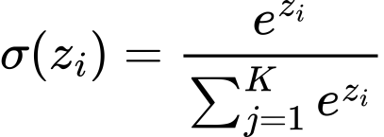
(1.2)
where z denotes the vector of raw logits and K is the total number of output classes. The softmax transformation maps the logits to a proper probability distribution, ensuring that all output values lie in the range (0, 1) and sum to exactly 1. This allows the model's output to be directly interpreted as class membership probabilities.
The final classification decision can then be derived from this probability distribution using several strategies. The simplest approach is argmax selection, which chooses the class with the highest assigned probability as the model's prediction. Alternatively, the top-N method can be employed, where the N classes with the highest probabilities are returned as candidate predictions, a scheme commonly used in evaluation benchmarks such as ImageNet, where top-5 accuracy is reported alongside top-1 accuracy.

TRANSFER LEARNING
As demonstrated by Zeiler & Fergus [18] through their DeconvNet visualization framework, convolutional layers learn to detect features of progressively increasing complexity as depth increases, from primitive low-level patterns such as edges and color gradients in the earliest layers, to mid-level structures such as textures and object parts in intermediate layers, and finally to high-level semantic representations in the deepest convolutional blocks. Crucially, this visualization work revealed that these learned feature hierarchies are not specific to any particular classification task, rather, they reflect general visual concepts that are broadly applicable across a wide range of image recognition problems.
This insight gave rise to the paradigm of transfer learning, the practice of reusing convolutional blocks from a large model pretrained on a substantial dataset, such as ImageNet, and replacing only the classifier head with a new, task-specific architecture suited to the target problem. The underlying intuition is straightforward: if a model has already learned to extract rich and general visual features from millions of diverse images, there is little justification for discarding that knowledge and retraining from scratch on a smaller, domain-specific dataset. Instead, the pretrained convolutional backbone is either fine-tuned by slightly tweaking parameter values of last N blocks or layers to better infer domain specific tasks or frozen completely and reused as is while only the newly attached classifier head is trained to map those features to the desired output classes.
This approach offers several significant practical advantages. First, it dramatically reduces the amount of labeled training data required to achieve high classification accuracy, since the backbone already captures general visual representations that would otherwise require enormous datasets to learn. Second, it substantially shortens training time, as only a fraction of the network's parameters need to be updated. Third, and perhaps most importantly, it consistently improves model performance when base model is selected for the same task it was trained for, such as using CNN trained on ImageNet-1K for image classification on smaller dataset. Pan & Yang [2] formally established the theoretical foundations of this approach, and subsequent empirical work has confirmed that selecting a relevant, domain-appropriate base model can yield significant accuracy gains over training from scratch, even when the available target dataset is relatively small.
In the context of plant disease recognition, transfer learning is especially well-motivated. The PlantVillage dataset, while substantial for an agricultural benchmark, remains orders of magnitude smaller than ImageNet. Training a deep architecture such as MobileNet from random initialization on such a dataset would risk severe overfitting and poor generalization. By initializing the convolutional backbone with ImageNet-pretrained weights and fine-tuning only the classifier head or selectively unfreezing the uppermost convolutional blocks the model benefits from a rich prior over visual features, enabling it to converge faster and generalize more reliably to unseen leaf images.

PLANT DISEASE DATASETS

PLANTVILLAGE
The foundation upon which the majority of deep learning research in plant disease recognition rests is the PlantVillage dataset, introduced by Hughes & Salathé [11] as an open-access repository of expertly curated leaf images hosted on the PlantVillage online platform. The authors recognized that a critical bottleneck in developing automated diagnostic tools was the absence of any large, freely available, verified image dataset for plant health. To address this gap, images were collected at experimental research stations associated with Land Grant Universities across the United States, photographed under controlled conditions against uniform backgrounds, and annotated by plant pathology experts. The resulting dataset contains 54,309 images organized into 38 classes spanning 14 crop species and 26 distinct diseases with images of healthy leaves added for reference. Dataset is openly accessible and released under the Creative Commons Attribution-ShareAlike 3.0 license, with the clarification that algorithms trained on the data fall under the same license. The dataset was explicitly designed as the foundation of an ongoing crowdsourcing effort, with the long-term vision of enabling smartphone-assisted disease diagnosis at a massive global scale, particularly for the smallholder farmers in the developing world who are most vulnerable to crop losses yet have the least access to expert agronomic advice.
Despite its widespread adoption and undeniable value to the research community, the PlantVillage dataset carries inherent limitations that are important to acknowledge. All images were collected under controlled laboratory conditions, with isolated single leaves placed against plain backgrounds, photographed under consistent lighting, which results in a distribution significantly different from the complex, variable conditions encountered in real agricultural fields. Models trained on PlantVillage dataset show outstanding performance in testing environments, with certain architectures [1] [6] achieving >99% accuracy. However, due to “perfect” nature of images in datatset, same models, when applied to real-world images, show underwhelming results, with CNN achieving ~31% accuracy [6] and ViT-MoE achieving 74% accuracy [1]. Furthermore, Noyan [20] identified label-correlated background biases in the dataset, showing that a model trained purely on background pixels could achieve well above random-chance accuracy, a finding that raises concerns about whether models are genuinely learning disease-relevant leaf features or exploiting dataset-specific artifacts.
Nonetheless, PlantVillage remains the most widely used benchmark dataset in the plant disease recognition literature and will serve as the primary training and evaluation resource for the model developed in this work.
. 
Figure 1.3 - Example images from PlantVillage dataset. Left image shows apple leaf infected by apple scab. Right image shows healthy apple leaf.

PLANTDOC
Recognizing the fundamental limitations of the PlantVillage dataset researchers from India sought to construct a more ecologically valid benchmark by compiling PlantDoc, a dataset explicitly designed to reflect the visual complexity of real-world agricultural environments [19]. Rather than collecting images under controlled conditions, the team curated their dataset by carefully scraping images from the internet and spent over 300 hours manually labeling them with the assistance of plant pathology experts. The resulting dataset comprises 2,598 images spanning 13 plant species and 17 disease classes, capturing the natural variability of field conditions, including inconsistent lighting, cluttered backgrounds, partial occlusions, and varying camera angles, that are entirely absent from PlantVillage.
For the purposes of this work, PlantDoc serves a specific and important role: rather than being used for training, it is employed exclusively as an independent validation benchmark. This experimental design, training on PlantVillage and evaluating on PlantDoc, allows for a principled assessment of the proposed model's ability to generalize beyond the controlled conditions of its training distribution, providing a more honest estimate of real-world deployment performance than in-distribution testing alone could offer.
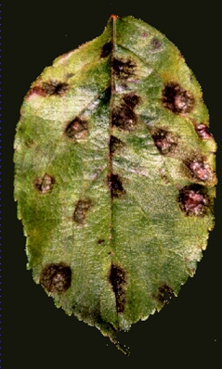
Figure 2.4 - Example images from PlantDoc dataset. Left image shows apple leaf infected by apple scab. Right image shows healthy apple leaf.

EXISTING PLANT DISEASE CLASSIFICATION MODELS

MOHANTY ET AL. [6]
One of the earliest and most influential demonstrations of deep learning applied to plant disease recognition was presented by Mohanty, Hughes & Salathé in 2016 [18]. Motivated by the lack of scalable diagnostic infrastructure in developing regions, where over 80% of agricultural production comes from smallholder farmers particularly vulnerable to crop losses, the authors framed automated image-based disease detection as both a technical and humanitarian challenge. Using the PlantVillage dataset, they systematically evaluated two best CNN architectures available at the time, massive AlexNet and smaller GoogLeNet, under multiple experimental configurations, including training from scratch versus transfer learning, and three image representations: color, grayscale, and background-segmented. Their best-performing configuration, GoogLeNet with transfer learning on color images using an 80/20 train-test split, achieved an overall accuracy of 99.34% and a mean F1 score of 0.9934 on the held-out PlantVillage test set. Notably, the authors also assessed real-world generalization by testing the trained model against 121 images sourced from agricultural extension services online, images captured under entirely different conditions from the training data. In this setting, top-1 accuracy dropped sharply to 31.4% and top-5 accuracy reached only 52.89%. The authors candidly acknowledged that a more diverse set of training data would be required to bridge this gap between controlled laboratory conditions and practical field deployment, a limitation that remains an active area of research to this day.
It is worth noting that this study was published in 2016, at a time when AlexNet and GoogLeNet represented the state of the art in CNN architecture design. Both architectures have since been substantially superseded by more efficient and accurate models. In particular, MobileNetV3 [23], which employs compound scaling to simultaneously optimize network depth, width, and resolution, has been shown to outperform both AlexNet and GoogLeNet on ImageNet by a significant margin while requiring considerably fewer parameters. Given that Mohanty et al. demonstrated strong results even with these older architectures, this work aims to utilize MobileNet as the backbone for transfer learned model, which, hopefully, will show better results then those achieved by AlexNet and GoogLeNet.

SALMAN ET AL. [1]
A more recent and notably more ambitious approach to plant disease classification was presented by Salman, Muhammad & Han (2025), who addressed one of the most persistent challenges in the field: the sharp performance degradation that occurs when models trained on controlled laboratory datasets are deployed in real-world agricultural environments. Rather than relying on CNN-based architectures, the authors proposed a novel framework combining a Vision Transformer (ViT) backbone with a Mixture of Experts (MoE) module, a gating-based architecture in which multiple specialized sub-networks, each trained to handle different aspects of the input data, are dynamically selected for each incoming image. To further improve robustness, the model incorporates both entropy regularization and orthogonal regularization, which discourage expert collapse and ensure balanced utilization of the specialist classifiers. Evaluated on the PlantVillage dataset, the model demonstrated 68% accuracy when applied to PlantDoc dataset surpassing strong CNN baselines on this benchmark. This represents a meaningful improvement over the 31.4% real-world accuracy reported by Mohanty et al. (2016), underscoring how far the field has progressed in bridging the lab-to-field generalization gap.
However, the architectural complexity of the ViT-MoE framework comes at a significant computational cost. Vision Transformers, by design, treat the input image as a sequence of flattened patches and compute full pairwise self-attention across all patches simultaneously, a process whose memory and computational requirements scale quadratically with image resolution. Unlike CNNs, ViTs lack the inductive biases of locality and translational invariance, which means they require substantially more data and computation to converge, and the resulting models are considerably larger and slower at inference time. While this may be acceptable in high-resource research settings or offline batch processing scenarios, it presents a fundamental obstacle for deployment in lightweight, real-time systems, such as a web-based plant disease prediction tool, that this work aims to create, accessible to farmers on standard hardware or mobile devices. For such applications, an architecture that balances strong classification accuracy with computational efficiency is far more appropriate. MobileNetV3 [23], with its compound scaling strategy and significantly lower parameter count, offers precisely this trade-off, making it a more suitable backbone for the system proposed in this work.

Ⅲ. SYSTEM DESIGN

GOALS AND OBJECTIVES
The primary aim of this work is to develop a web-based system that provides users worldwide with accessible, easy-to-use tooling for automated classification of plant diseases using a neural network. To achieve this, the following core objectives have been identified:
1. Open Source - All components of the system, including model weights, source code, training pipelines, and user documentation, shall be made fully open source. This ensures that any individual, researcher, or organization worldwide can deploy the system independently, adapt it to their specific needs, and contribute improvements back to the community. This objective is particularly important in the context of smallholder farming communities in developing regions, where access to proprietary commercial solutions is often economically infeasible.
2. Speed and Efficiency - Computational efficiency is a primary design consideration. While the system is not intended for extreme edge deployment such as embedded microcontrollers, it must remain practical for users and organizations without access to high-end hardware infrastructure. This constraint directly motivates the choice of a lightweight CNN-based architecture over more computationally demanding alternatives such as Vision Transformers, which, despite latter strong performance, impose prohibitive resource requirements for inference and training.
3. Ease of Use for End Users - The user interface shall be intuitive, uncluttered, and accessible to users with varying levels of digital literacy. The system should require no specialized knowledge to operate. A user should be able to upload a leaf image and receive a meaningful diagnostic result with minimal friction.
4. Ease of Use for Developers - The system architecture shall be designed with deployability and maintainability in mind, enabling other developers to run, modify, and extend the system with minimal overhead. Clear documentation and a modular codebase are considered first-class requirements alongside functional correctness.
5. Security and Reliability - As a publicly accessible web-facing system, the application must be reasonably protected against threats inherent to the web environment. Stability and graceful handling of unexpected inputs are considered essential properties for a system intended for broad public use.
The development of this system is subject to the following key challenges:
1. Generalization - As discussed in the literature review, models trained on controlled benchmark datasets such as PlantVillage consistently exhibit a significant drop in performance when evaluated against real-world field images. Bridging this domain gap represents the most fundamental technical challenge of this work. Furthermore, given that no currently available model achieves reliable real-world accuracy, the system shall present the user with multiple candidate predictions rather than a single classification result, in order to not misguide user by providing invalid information.
2. Training Data Quality - Both PlantVillage and PlantDoc, while invaluable resources, carry inherent limitations, including controlled acquisition conditions, class imbalance, and dataset-specific biases, that are likely to affect the generalization capability of any model trained on them. These limitations must be carefully considered during the training process.
3. Web Deployment Constraints - Serving a trained deep learning model within a web environment introduces a distinct set of technical challenges separate from model training, including model serialization, inference latency, and memory management under concurrent user load. These constraints impose additional requirements on the choice of architecture and the design of the serving infrastructure.

WEB MODULE

SYSTEM FUNCTIONS
To address the objectives presented in the Goals and Objectives chapter, the web system must be capable of performing the following functions:
1. Disease Classification - For the purposes of executing its primary function, the system must accept a valid image file submitted by the user and return the top-5 most likely disease classification candidates along with their associated confidence scores. This multi-candidate output strategy acknowledges the inherent uncertainty of real-world plant disease recognition and provides more actionable diagnostic information than a single hard prediction.
2. File Validation - Prior to passing any uploaded file to the classification model, the system must validate that the submitted file is a genuine image of an accepted format and does not exceed a defined size threshold. Files failing validation must be rejected with a clear, informative error message. This function serves both as a reliability safeguard and as a basic security measure against malicious or malformed file uploads.
3. Result Presentation - The system must present classification results to the user in a clear, human-readable format. Confidence scores must be displayed alongside each candidate prediction in a manner that is interpretable by users without a machine learning background.
4. Error Handling - The system must handle failure conditions gracefully and transparently. In the event of an invalid input, a failed inference, or service unavailability, the user must receive a meaningful and actionable error message rather than a raw technical error or silent failure.
5. Responsive User Interface - The user interface must be fully functional and visually coherent across a range of devices and screen sizes, including desktop browsers and mobile devices. Given that a significant portion of the target user base in agricultural and developing-world contexts accesses the internet primarily via smartphone, mobile compatibility is considered a first-class requirement.
6. Rate Limiting - For the purposes of maintaining system stability and balancing server-wide load, the system must implement request rate limiting at the server level, capping the total number of requests processed within a given time window regardless of their origin. This prevents resource exhaustion under high concurrent load and ensures consistent availability for all users.
7. Configurability - For the purposes of maintainability and flexible deployment, the system must expose all operationally significant parameters, such as rate limiting thresholds, maximum file upload size, accepted file formats, server port, and other runtime values, through a centralized configuration interface. This allows the system to be adapted to different deployment environments and hardware constraints without requiring code changes or redeployment, and ensures that developers running the system for their own purposes can tune its behaviour to their specific needs.

SYNTHESIS OF STRUCTURE - FRONTEND
To implement functions mentioned in System Functions chapter, the following structure of the frontend is proposed.
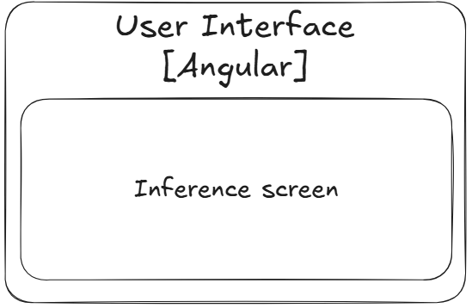
Figure 3.1 - Front end module container diagram
The frontend module serves as a straightforward and focused interface for the system's primary purpose, submitting plant leaf images for disease classification and presenting the resulting predictions to the user. In keeping with the ease-of-use objective established in the Goals and Objectives chapter, the user interface is intentionally minimal, exposing only the functionality necessary to fulfil the system's core function without unnecessary complexity.
To this end, the frontend consists of a single module:
Inference Screen - Upon navigating to the root page of the application, whether from a desktop browser or a mobile device, the user is greeted with the inference screen, which serves as the sole point of interaction with the system. The layout is fully responsive, adapting gracefully to a wide range of screen sizes and orientations to ensure a consistent experience across device types.
From this screen, the user may upload an image of a plant leaf they wish to analyze. Prior to submission, the interface validates that the selected file meets the required format and size constraints, providing immediate and informative feedback should the file be deemed invalid, preventing unnecessary round trips to the server and reducing user confusion. Upon submitting a valid image, a loading indicator is displayed for the duration of the server-side inference process, communicating to the user that their request is being processed and preventing the perception of an unresponsive interface.
Once the server returns a response, the inference results are presented directly on the same screen in a clear, human-readable format, displaying the top-5 most likely disease classifications alongside their respective confidence scores in a manner interpretable by users without a machine learning background. To comply with Error Handling system function, should the server return an error, whether due to a processing failure, service unavailability, or any other unexpected condition, the screen displays a meaningful and actionable error message in place of the results, ensuring the user is never left without feedback.
The frontend module is implemented using Angular as the framework of choice. Angular's opinionated, component-based architecture enforces a clear separation of concerns and provides a well-defined project structure out of the box, significantly reducing the overhead associated with architectural decision-making during development. Its wide and mature ecosystem offers convenient, well-maintained solutions for common frontend requirements, including reactive forms, HTTP client integration, and responsive layout tooling, many of which are directly applicable to the needs of this system. Additionally, prior familiarity with the framework on the part of the developer of this project allows development effort to be directed toward solving domain-specific problems rather than navigating an unfamiliar toolchain..

SYNTHESIS OF STRUCTURE - BACKEND
To implement functions mentioned in System Functions chapter, the following structure of the backend is proposed.
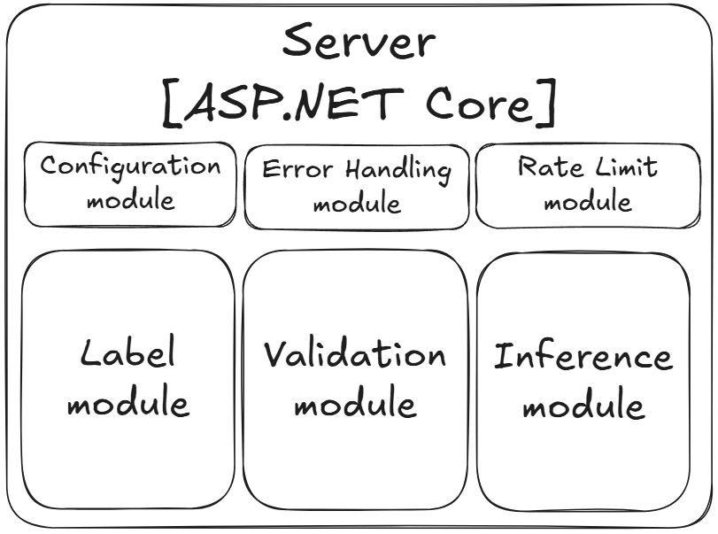
Figure 3.2 - Backend module container diagram
The backend module serves as the intermediary layer between the frontend and engine modules, acting as the primary gatekeeper responsible for controlling access, validating incoming data, and coordinating communication between system components. It is implemented using ASP.NET Core with a controller-based architecture, exposing a defined set of API endpoints through which the frontend communicates with the rest of the system. The backend consists of the following modules:
1. Configuration Module - The configuration module is responsible for loading and exposing all operationally significant runtime parameters required by the backend and ASP.NET Core itself, including rate limiting thresholds, file size limits, and accepted file formats. All configurable values are sourced from a centralized configuration interface, ensuring that the system can be adapted to different deployment environments without requiring code changes.
2. Rate Limiting Module - The rate limiting module is responsible for enforcing a server-wide cap on the number of requests processed within a given time window, with the maximum threshold defined by the configuration module. Requests exceeding this limit are rejected before reaching any downstream processing logic, protecting the system from resource exhaustion under high concurrent load and ensuring consistent availability for all users.
3. Validation Module - The validation module is responsible for confirming the integrity and acceptability of data submitted by the frontend before it is passed to any downstream module. This includes verifying that uploaded files are of an accepted format and do not exceed the configured size threshold. Any request failing validation is rejected at this stage with a clear and informative error response, preventing malformed or potentially malicious data from reaching the inference pipeline.
4. Inference Module - The inference module is responsible for accepting validated image data from the frontend and forwarding it to the external engine module for processing. Upon receiving the engine's response, the module returns resulting classifications along with their associated confidence scores to the frontend for presentation to the user.
5. Label Module - The label module is responsible for retrieving the complete set of classification labels from the engine module on application startup.
6. Error Handling Module - The error handling module acts as a global exception handler, intercepting any unhandled errors that propagate through the request pipeline before they reach the frontend. Rather than exposing raw stack traces or cryptic HTTP error codes, the module ensures that all failure conditions are translated into consistent, meaningful, and user-appropriate error responses, maintaining a predictable API contract regardless of the nature of the underlying failure.

SYNTHESIS OF STRUCTURE- ENGINE
To implement functions mentioned in System Functions chapter, the following structure of the engine is proposed.
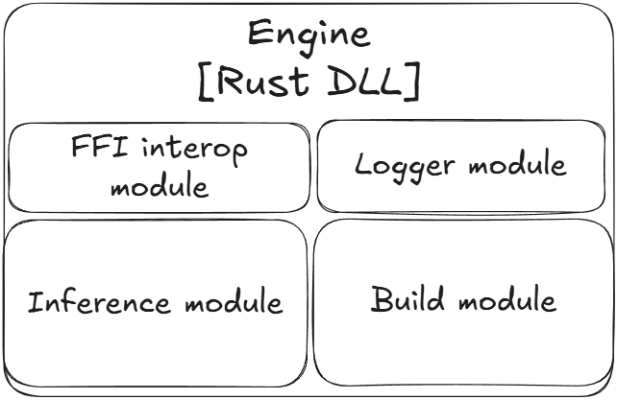
Figure 3.3 - Engine module container diagram
The engine module serves as the primary execution environment for model inference. It is implemented in Rust using the Burn deep learning library and compiled into a dynamic-link library (DLL) that is loaded directly by the backend module at runtime. This architecture isolates the computationally intensive inference logic from the backend, allowing each component to be developed, tested, and updated independently. A key architectural property of the engine is that it is entirely self-contained, both the model weights and metadata are baked directly into the compiled DLL binary at compile time, meaning no external files are required at runtime.
The engine consists of the following modules:
1. Build Module - The build module operates exclusively at compile time via Burn's build pipeline and is responsible for transforming external source model artifacts into native Rust representations that are embedded directly into the binary. Specifically, the module ingests the model in ONNX format and transforms it into a generated Rust file representing the network architecture and weights as a native Burn model struct. In parallel, a metadata.json file containing model metadata, including class labels and input size is parsed and transformed into a generated metadata.rs file representing the metadata as a native Rust struct. Both generated files are incorporated into the binary at compile time via Rust's include! macro, ensuring that the final compiled DLL requires no external files to be present at runtime.
2. FFI Interop Module - The FFI interop module is responsible for exposing the engine's functionality across the language boundary between Rust and C#. It implements the set of extern "C" functions required for cross-language interoperability, providing the backend module with a stable, well-defined C-compatible interface through which it can invoke inference, retrieve labels, and initialize the engine without any knowledge of Rust's internal type system or memory model.
3. Logger Module - Since the engine operates as a DLL loaded into the ASP.NET Core process, its internal logging must be integrated into the host application's logging pipeline rather than operating independently. The logger module is responsible for implementing a custom Rust logging backend that forwards log messages emitted by the engine to ASP.NET Core's logging infrastructure, ensuring that engine-side events — including errors, warnings, and diagnostic information — are captured and surfaced consistently alongside backend logs.
4. Inference Module - The inference module is the core computational component of the engine, responsible for accepting raw image bytes forwarded from the backend via the FFI interop module and executing the classification pipeline. This includes decoding the raw bytes into a tensor representation, applying the necessary preprocessing transformations, running a forward pass through the embedded Burn model, and returning the resulting output logits to the backend for further processing into top-5 classification candidates.
5. Metadata Module - The metadata module is responsible for exposing the model metadata embedded at compile time — including the full set of classification labels, model name, and version information — to the backend via the FFI interop module. Since metadata is static for the lifetime of the application, it is read directly from the embedded metadata.rs struct and returned on demand without any runtime file access or additional processing overhead.

MODEL TRAINING

ASSESSMENT OF DATASETS
For training, two datasets are utilized: PlantVillage and PlantDoc. As discussed in the previous chapter, PlantDoc will be used exclusively as an independent validation benchmark and will not be included in the training loop itself, serving as a measure of the model's ability to generalize beyond the controlled conditions of its training distribution.
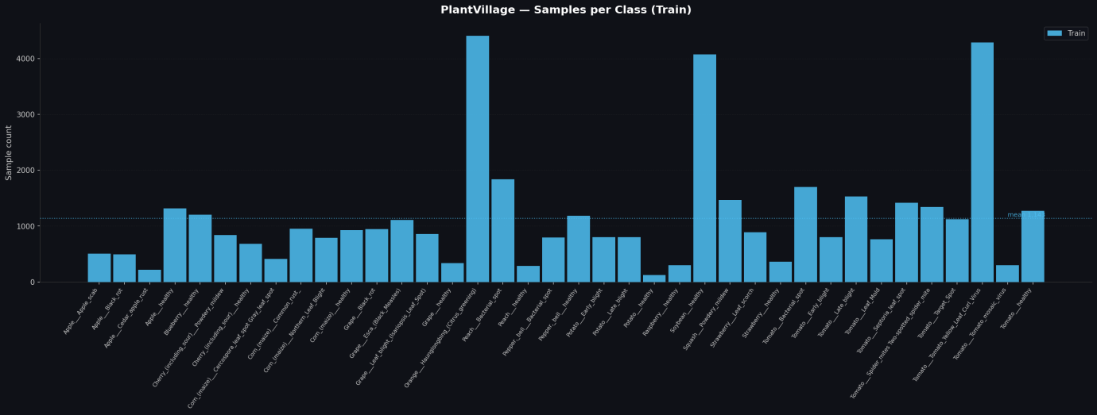
Figure 3.4 - Number of train samples for every class in PlantVillage dataset
As evident from Fig. 3.4, the PlantVillage training set is notably unbalanced, while the majority of classes cluster around a mean of approximately 1,200 samples, a small number of classes are significantly overrepresented, exceeding 4,000 samples, while others fall as low as 200. To investigate the effect of this imbalance on model performance, data augmentation strategy is treated as one of the experimental hyperparameters, with two distinct variants evaluated.
The first variant establishes a baseline by training the model on the raw PlantVillage dataset without any augmentation applied, allowing the effect of class imbalance to be observed in isolation. The second variant applies TrivialAugment [3] uniformly across all classes during training, a parameter-free augmentation strategy that randomly selects and applies a single augmentation operation at a randomly sampled intensity per training image, without requiring any manual tuning of augmentation hyperparameters.

MODEL SELECTION
As the backbone for the transfer learning model, MobileNetV3 [23] is selected as the base architecture. MobileNetV3 represents a compelling balance between classification performance and computational cost, making it well-suited for the efficiency requirements established in the Goals and Objectives chapter. Large and small variant will be evaluated in this work: MobileNetV3-Small and MobileNetV3-Large, offering a meaningful range of model capacity within practical hardware constraints.

FINE-TUNING STRATEGY
The third and final experimental hyperparameter concerns the fine-tuning strategy applied to the MobileNetV3 backbone. In the transfer learning paradigm, the pretrained backbone can be kept entirely frozen, preserving the ImageNet-learned feature representations without modification, or selectively unfrozen to allow the model to adapt its higher-level representations to the specific visual characteristics of the target domain.
Three variants are evaluated: a fully frozen backbone (N=0), in which only the classifier head is trained and all backbone weights remain fixed at their pretrained ImageNet values; partial fine-tuning with the last 1 block unfrozen (N=1), representing a conservative adaptation that allows only the most domain-specific, high-level feature extraction layers to update; and partial fine-tuning with the last 3 blocks unfrozen (N=3), allowing a broader portion of the backbone to adapt to the plant disease domain while preserving the general low-level and mid-level feature representations learned from ImageNet in the earlier stages.
This axis is motivated by the hypothesis that while ImageNet-pretrained features are broadly transferable, the highest-level convolutional representations, which encode the most task-specific semantic concepts, may benefit from adaptation to the visual characteristics of diseased plant leaves, potentially improving the model's ability to generalize across the domain gap between PlantVillage's controlled conditions and real-world field images.

Ⅳ. SOFTWARE IMPLEMENTATION

FRONTEND
The frontend module is implemented as a single-page Angular application consisting of four components and five services, organized under a single root application module. The project follows Angular's standard directory conventions, with components grouped under src/app/components and services under src/app/services.

PROJECT STRUCTURE
The application is composed of the following components and services:
Components:
app - The root component serves as the top-level composition layer, orchestrating the interaction between the image-upload and prediction-result components. Communication between the two components is handled via Angular's standard input/output binding mechanism - image-upload emits an onImageReady event carrying the preprocessed image blob upon successful file selection, which app receives and stores in a signal via selectedImageData. This value is then passed downward to prediction-result as an input binding, which uses it to trigger the inference request and subsequently display the results. This unidirectional data flow keeps each component focused on a single responsibility while maintaining a clean and explicit communication contract between them.
image-upload - responsible for rendering the drag-and-drop file upload area, accepting PNG, JPG, and WEBP formats, and preprocessing the uploaded image prior to submission. Upon file selection, the image is drawn onto a canvas element explicitly sized to the model's expected input dimensions, retrieved from the backend via MetadataService, and the resized result is extracted from canvas by calling toBlob method, producing a PNG-encoded blob of the correct dimensions regardless of the original file's size or format. This ensures that the backend always receives an image of the expected input size without requiring any server-side resizing, and simultaneously provides the user with a visual preview of the image as it will be submitted to the model. After resizing is done, image-upload component provides app component with blob that is ready for upload to backend.
prediction-result - responsible for managing the inference lifecycle and presenting classification results to the user. The component receives the preprocessed image blob from app via input binding and remains in a locked state until a valid image is available, at which point the submit button is enabled. Upon the user pressing the button, the component dispatches the image to the backend via InferenceService and receives in return a vector of 38 raw unnormalized logits, one per PlantVillage class. Softmax is applied on the frontend to convert the logits into a proper probability distribution, after which the top-5 candidates are selected by sorting the resulting probabilities in descending order and taking the five highest-scoring entries. This design is intentional, by delegating softmax and top-N selection to the frontend, the engine is kept as simple and stateless as possible, with its sole responsibility being the execution of the forward pass and the return of raw logits.
data-bar - a dedicated component encapsulating the animated confidence bar rendered within each prediction result row, extracted into its own component to isolate animation logic and prevent rendering conflicts that arise when animation is handled inline
Services:
ConfigService - centralizes all configuration values consumed by the frontend, including the base API URL, versioned API slug, and the set of endpoint paths for labels, input size, and inference. This ensures that any change to the backend's address or API structure requires modification in a single location rather than across multiple call sites
HttpClientWrapperService - provides a typed abstraction layer over Angular's built-in HttpClient, centralizing backend endpoints as convenient functions for consuming services, which don’t need to know about HTTP contract.
InferenceService - responsible for dispatching the preprocessed image blob to the backend inference endpoint and returning the raw logit vector to the calling component. The image is transmitted as a binary application/octet-stream request body, avoiding the overhead of multipart form encoding and keeping the request as lightweight as possible.
MetadataService - fetches both the classification label set and the model input size from their respective backend endpoints on first access, caching each response using RxJS’s Observable class shareReplay(1) function via pipe method to ensure that subsequent subscriptions receive the cached value without triggering additional HTTP requests for the lifetime of the application
MobileObserverService - wraps Angular CDK's BreakpointObserver with a breakpoint threshold of 1,100px, which was experminetally determined to be a point where desktop layout breaks and switch to mobile is needed, exposing an observable that emits whether the current viewport is considered a mobile device, allowing components to adapt their layout accordingly
User Interface:
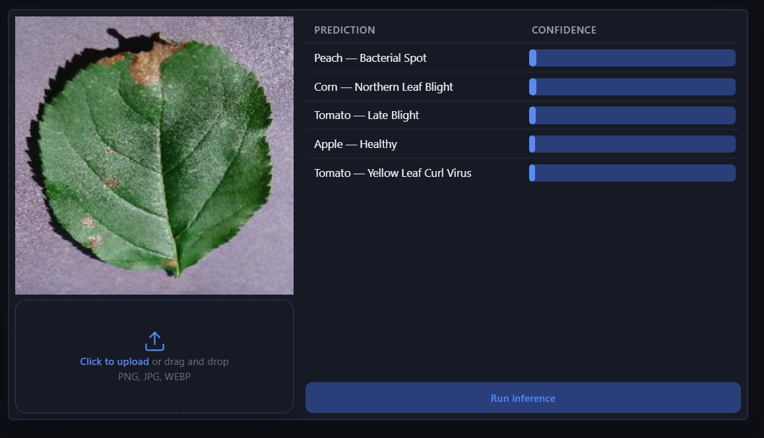
Figure 4.1 - Screenshot of desktop frontend after prediction has been made

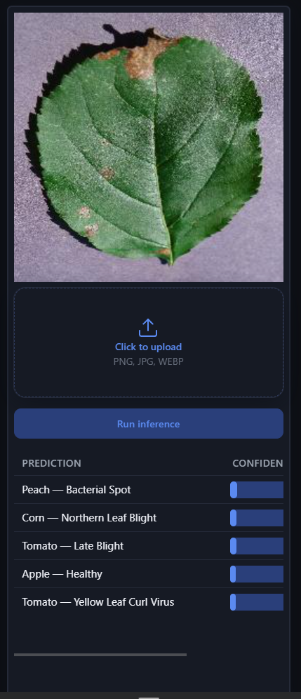
Figure 4.2 - Screenshot of desktop frontend after prediction has been made
As shown in Fig. 4.1, the inference screen presents the user with a two-panel layout. The left panel contains the image upload area - a dashed dropzone that accepts drag-and-drop or click-to-upload interaction, displaying the accepted file formats to the user. Upon selecting a valid image, the file is rendered onto a canvas element and resized to the model's expected input dimensions, giving the user visual confirmation of the submitted image. The right panel contains the results table, headed by Prediction and Confidence columns, which is populated with the top-5 classification candidates and their associated confidence scores once the server returns a response. A status bar at the bottom of the results panel communicates the current state of the application to the user, displaying a prompt to upload an image in the idle state, a loading indicator during inference, and an error message should the request fail.
The layout is fully responsive, transitioning to a single-column stacked arrangement on viewports narrower than 1,100px, ensuring consistent usability on mobile devices without requiring a separate mobile interface, as shown on Fig 4.2.

BACKEND
The backend module is implemented in ASP.NET Core and is organized into three distinct projects, each with a clearly defined responsibility: PlantDiseaseDetection.WebApi.Api serves as the main application host, PlantDiseaseDetection.Engine.Contracts defines the abstraction boundary between the API and the engine and PlantDiseaseDetection.Engine.Rust provides the concrete implementation that communicates with the Rust DLL.

PLANTDISEASEDETECTION.WEBAPI.API
The main API project contains all ASP.NET Core infrastructure, such as controllers, configuration, middleware, and exception handling, and serves as the composition root of the application.
Configuration - Application configuration is handled via ApiConfiguration class, which is loaded from appsettings.json at startup and eagerly validated, ensuring that any missing or malformed configuration values cause the application to fail fast at startup rather than at runtime when the values are first consumed. Configuration values include rate limiting configuration and device used for inference by engine. The ConfigurationExtensions class provides the registration logic that binds the configuration section to the typed ApiConfiguration object and registers it with ASP.NET Core's dependency injection container.
Controllers The API exposes two controllers:
InferenceController - accepts incoming image data as a binary application/octet-stream request body and forwards it to the engine via IInferenceEngine, returning the resulting vector of 38 raw logits to the caller. The controller operates exclusively on streams, avoiding unnecessary buffering of the image data into memory. Exposed HTTP endpoints: POST /api/v{apiVersion}/inference
MetadataController - exposes two endpoints serving the classification label set and the model input size, both sourced from IMetadataSource. These values are static for the lifetime of the application and are cached at the engine layer, so the controller simply delegates to the interface without any additional caching logic. Exposed HTTP endpoints: GET /api/v{apiVersion}/metadata/labels, GET /api/v{apiVersion}/metadata/input-size.
API Versioning API versioning is managed via ASP NET Core’s out-of-the-box tooling via AddApiVersions and actual versions defined inside controllers. ApiVersions holds constants for unification of API versions for convenience.
Error Handling Global exception handling is implemented via GlobalExceptionHandler, registered as an ASP.NET Core exception handler. It intercepts all unhandled exceptions propagating through the request pipeline and maps them to consistent, structured JSON error responses using the ErrorResponse model defined in the Utils folder, ensuring that the frontend always receives a predictable error contract regardless of the nature of the underlying failure.
Rate Limiting Request rate limiting is implemented using ASP.NET Core's built-in UseRateLimiter middleware, configured with thresholds sourced from ApiConfiguration. This enforces a server-wide cap on the number of requests processed within a given time window, protecting the system from resource exhaustion under high concurrent load.

PLANTDISEASEDETECTION.WEBAPI.ENGINE.CONTRACTS
The contracts project defines the abstraction boundary between the API layer and the engine implementation, consisting of two interfaces:
IInferenceEngine - defines a single asynchronous method InferAsync(Stream data, int width, int height) returning IReadOnlyList<float>, representing the raw logit vector produced by the model. Accepting a Stream rather than a byte array avoids unnecessary memory allocation and keeps the interface agnostic to the source of the image data.
IMetadataSource - defines two methods: GetLabels returning IReadOnlyList<string> and GetInputSize returning IReadOnlyList<int>, providing the API layer with access to model metadata without any dependency on the Rust implementation details.
This separation ensures that the API project has no direct dependency on the Rust DLL or any FFI-related code, and that the engine implementation can be swapped out, for example, for a mock implementation during testing, without any changes to the API layer.

PLANTDISEASEDETECTION.WEBAPI.ENGINE.RUST
The Rust engine project provides the concrete implementations of both contracts and manages all aspects of communication with the native Rust DLL.
DLL Interop All native interop is centralized in the Wrappers folder, which consists of three files:
DllConstants.cs - defines the DLL location as an internal constant (engine.dll), providing a single point of change should the DLL path or name need to be updated
RustModels.cs - defines the C#-side representations of data structures exchanged across the FFI boundary, ensuring correct memory layout for marshalling between managed and unmanaged memory
RustWrapper.cs - contains all [DllImport] P/Invoke declarations, mapping the extern "C" functions exposed by the Rust DLL to callable C# methods
Engine Services Four services build upon the wrapper layer to provide higher-level functionality:
RustInferenceEngine - implements IInferenceEngine, accepting image data as a stream and forwarding it to the Rust DLL via RustWrapper, returning the resulting logit vector to the caller
RustMetadataSource - implements IMetadataSource, retrieving classification labels and input size from the DLL. Since both values are static for the application lifetime, they are fetched once and cached in memory, with subsequent calls served directly from cache
RustModelInitializerService - registered as a hosted service, this is responsible for initializing the Burn model on application startup. Since Burn performs certain optimization and compilation steps on first load, eager initialization at startup ensures that the first inference request is not penalized by this one-time overhead
RustLoggerService - integrates the Rust DLL's internal logging pipeline into ASP.NET Core's ILogger infrastructure by passing a raw function pointer to the DLL at initialization time. This allows log messages emitted by the engine to surface through the standard .NET logging pipeline alongside backend logs, providing a unified and consistent observability experience
Device Configuration The DeviceType enum, with Cpu and Gpu variants, is loaded from appsettings.json via ApiConfiguration, allowing the inference device to be selected at deployment time without code changes. This is registered and wired into the engine via the IoC Extensions.cs class, which registers all engine services into ASP.NET Core's dependency injection container.

ENGINE
The engine module is implemented in Rust using the Burn deep learning library and compiled into a native DLL (engine.dll) that is loaded by the backend at runtime. The module is entirely self-contained, both the model weights and metadata are baked into the binary at compile time, requiring no external files to be present at runtime. The project is structured around a flat set of modules under src/, each with a clearly defined responsibility.

BUILD
The build process is coordinated by two scripts operating at different stages:
build.py serves as the top-level build orchestrator, invoking compiling the Rust project and copying the resulting dll to the location expected by the backend. This provides a single entry point for producing a deployment-ready engine binary.
build.rs is the Rust build script executed by Cargo before compilation. It implements the compile-time transformation pipeline using Burn's build utilities, reading the model in ONNX format and the metadata.json file and emitting two generated Rust source files: model.rs, containing the full network architecture and weights as a native Burn model struct, and metadata.rs, containing the model metadata, including input shape and label set, as a native Rust struct. Both generated files are incorporated into the binary at compile time via Rust's include! macro inside models/mod.rs:
This approach ensures that the final compiled DLL is fully self-contained, no ONNX file, no JSON file, and no external assets of any kind are required at runtime.

MODULE
lib.rs serves purely as the crate root, containing only mod declarations that bring all other modules into scope. No logic resides here, keeping the entry point clean and navigable.
models/mod.rs incorporates the build-time generated model and metadata structs via include!, making them available to the rest of the crate as the effnet_b0 module.
array.rs defines three FFI-safe array structs for number of types, each consisting of a raw pointer and a length, representing heap-allocated Rust vectors that have been surrendered to manual memory management via std::mem::ManuallyDrop. Each struct is accompanied by a corresponding free_* function exported via FFI, allowing the C# side to release the memory once it has consumed the data, preventing memory leaks across the FFI boundary.
inference.rs is the core computational module of the engine. It defines the ImageView struct, a structure carrying a raw pointer to image bytes along with width, height, and channel dimensions, which serves as the primary data transfer object across the FFI boundary for image data. The module exposes four DLL functions:
init_model_cpu() and init_model_gpu() - perform eager model initialization on the respective device by instantiating the model and running a single forward pass on a zero tensor. This forces Burn to start tuning process on application startup instead of first inference, saving time for end user, but increasing startup time.
run_inference_on_cpu(view: ImageView) and run_inference_on_gpu(view: ImageView) - accept an ImageView from the C# side, convert it to a Burn tensor via image_view_to_tensor, run a forward pass through the embedded model, and return the resulting logits as a FloatArray.
input_size.rs reads the input size embedded in the generated metadata.rs at compile time and exposes it via an DLL function, allowing the C# side to retrieve the model's expected input dimensions without any runtime file access.
labels.rs follows the same pattern for the classification label set, reading the labels from the embedded metadata struct and exposing them via an DLL function returning a StringArray.
logger.rs integrates the Rust logging pipeline into ASP.NET Core's logging infrastructure. It accepts a function pointer from the C# side at initialization time and registers a custom Rust logger implementation that forwards all log! macro calls to the provided callback. This allows engine-side log messages, including debug output from inference runs, to surface through the standard .NET ILogger pipeline alongside backend logs, providing a unified observability experience across the language boundary.

TRAINING
The training module is implemented in Python using torch and torchvision, serving as the end-to-end pipeline for training, evaluating, and exporting the plant disease classification model.

CONFIGURATION
Training is driven entirely by config.json, which declaratively defines the full experiment matrix. The run_config section specifies arrays of values for each hyperparameter, unfrozen block count, augmentation toggle, and model name, which are expanded into a flat list of all combinations. The run_settings section defines fixed parameters shared across all runs, including epoch count, batch size, and number of data loader workers. Dataset directories and output path are also specified here, making the entire training pipeline reproducible and configurable without code changes.

DATASET PREPARATION
Training and testing data is sourced from PlantVillage, while PlantDoc serves exclusively as an independent validation benchmark, it is never included in the training loop. Data loading is handled via torchvision.datasets.ImageFolder, with the transform pipeline varying based on the augmentation configuration. When augmentation is enabled, TrivialAugmentWide is applied to the training set. Evaluation transforms, center crop and normalization, are applied consistently to all splits regardless of augmentation setting.
PlantDoc class names are mapped to their PlantVillage equivalents prior to validation, allowing the out-of-distribution benchmark to be evaluated against the model's 38-class output without any changes to the model or its classifier head. Human-readable class labels, used later in the exported metadata, are generated by transforming raw PlantVillage directory names into formatted strings suitable for display in the frontend, for example, Apple___Apple_scab becomes Apple - Apple Scab

MODEL
The classification model is MobileNetV3-Large, loaded with DEFAULT pretrained ImageNet weights via torchvision. The original classifier head is replaced with a task-specific sequential block, consisting of, in order, Linear(960, 1024), Hardswish, Dropout(0.2) and Linear(1024, 38) layers.
Fine-tuning depth is controlled by the unfrozen_blocks hyperparameter. When set to zero, the entire backbone is frozen and only the classifier head is trained. For values greater than zero, the last N layers of model.features are unfrozen, allowing the highest-level feature extraction stages to adapt to the plant disease domain while preserving the general representations learned from ImageNet in earlier layers.

TRAINING LOOP
Each training run is executed by loop.py, which implements the full epoch loop over train, test, and validation splits. The optimizer is SGD with momentum 0.9 and weight decay 1e-4, applied across all trainable model parameters. The learning rate schedule combines a linear warmup over the first 5 epochs with cosine annealing for the remainder of training, implemented via PyTorch's SequentialLR. The loss function is CrossEntropyLoss.

EXPERIMENT TRACKING
For each epoch, metrics for every step are saved in form of confusion matrix and loss. Later, accuracy, precision, recall and F1 are calculated from confusion matrix and saved using ExperimentTracker class, which acts as a wrapper around tensorboard’s SummaryWriter. Later, logs from training can be viewed via tensorboard web dashboard and analyzed.

MODEL EXPORT
Upon completion of training, the model is set to evaluation mode and exported to ONNX format using PyTorch's onnx module.
Alongside the ONNX file, a metadata.json file is written containing the model's input shape and the full set of human-readable class labels.
Both files are consumed by the Rust engine's build pipeline at compile time, where they are transformed into native Rust structs and baked directly into the engine DLL as described in the engine implementation chapter.

MODEL

BROAD SWEEP
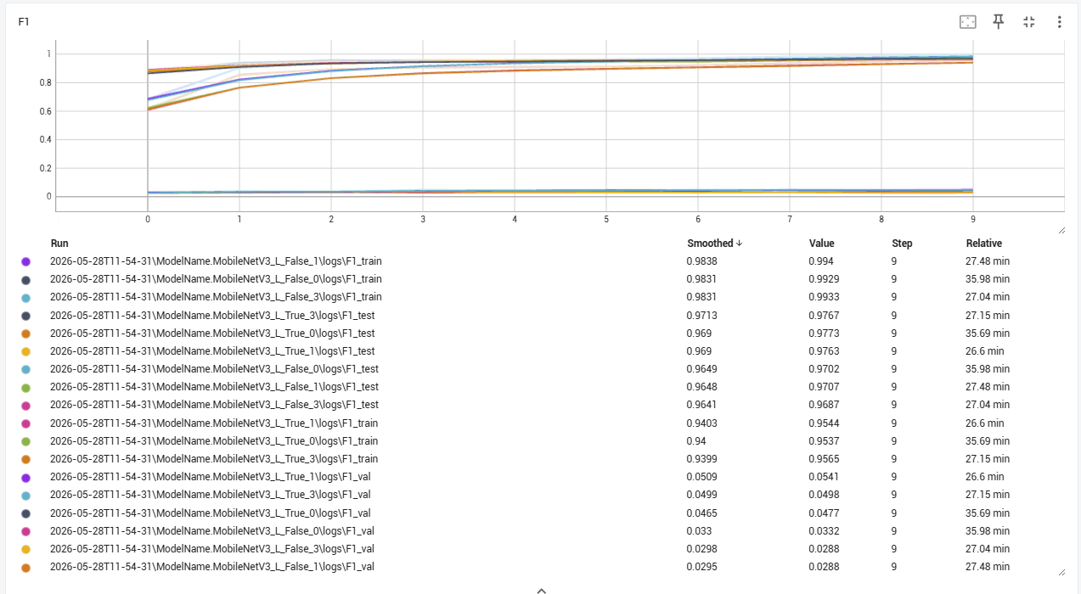
Figure 4.3 - Result of initial experiments
As the first stage of the experimental pipeline, a broad sweep of training runs was executed across the full combination matrix defined in the Training chapter, varying base model variant, augmentation strategy, and number of unfrozen backbone blocks, with each run trained for 10 epochs to identify the most promising candidate for extended training.
As evident from Fig. 4.3, model performance varies considerably between the PlantVillage test set and the PlantDoc validation benchmark across all configurations, confirming the domain gap discussed in the Literature Review. On the PlantVillage test set, the highest F1 score of 97% was achieved by the MobileNetV3-Large variant with augmentation enabled and 3 unfrozen blocks, suggesting that greater backbone adaptation benefits in-distribution performance. However, on the PlantDoc validation set, which serves as the primary indicator of real-world generalization, the strongest performer was the MobileNetV3-Large variant with augmentation enabled and 1 unfrozen block, achieving a notably higher out-of-distribution F1 score than any other configuration.
Given that generalization to real-world field conditions is the primary objective of this work, the PlantDoc validation performance was treated as the decisive selection criterion. The model with augmentation enabled and 1 unfrozen block was therefore selected as the candidate for extended training over the full 25 epochs.

FINAL MODEL
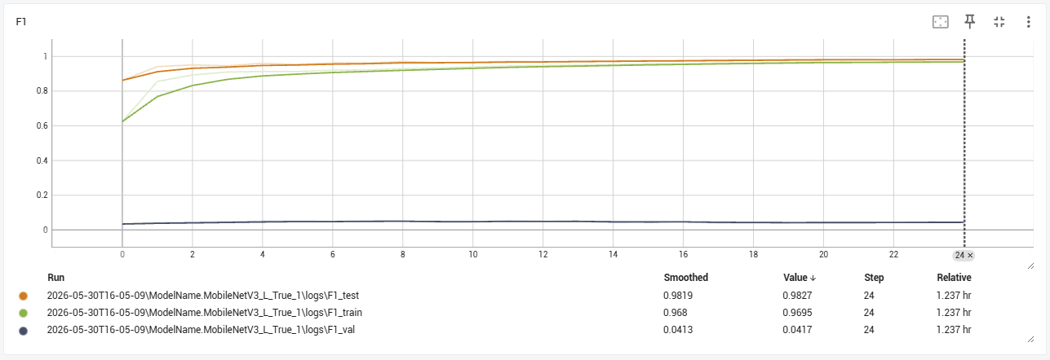
Figure 4.4 - Result of final experiment
The selected candidate, MobileNetV3-Large with augmentation enabled and 1 unfrozen block, was trained for the full 25 epochs. As shown in Fig. 4.4, the final model achieved 98.27% accuracy on the PlantVillage test set, demonstrating strong in-distribution classification performance consistent with the results reported in the literature for models trained on this benchmark. However, accuracy on the PlantDoc validation set stood at 4.17%, a sharp drop that, while stark, is consistent with the domain gap challenges documented throughout the literature review and reaffirms that controlled laboratory training data remains a fundamental limitation for real-world deployment, regardless of the architecture employed.

V. USER GUIDE

RUNNING PROJECT
Before running project, following prerequisites must be satisfied on system:
- Python 3.13 must be installed, along with uv package manager for Python.
- Latest rust toolchain must be installed.
- Dotnet SDK version 10.X must be installed.
- Node.js version 24.15.0 and npm version 11.12.1
- Model and metadata must be installed. This can be done by either training model manually or downloading existing one from repository that is linked in Appendix 1.
For manual model training, following steps must be followed.
- Edit config.json under ml folder and set parameters for training. Optional, as default parameters can be used.
- Download data using tools/get_data.py
- From ml folder, create virtual environment using uv sync.
- Start training using uv run main.py and wait until it is finished.
Alternatively, pretrained model found it models folder can be used.
Next step is to build engine DLL. To do this, follow next steps:
- In case custom model was built, edit engine/build.rs, to point at ONNX and metadata file produced by latest run.
- Run python build.py from engine folder, which will build Rust DLL and copy it to the place that WebApi expects it to be.
Finally, to start web application, follow those steps:
- Run dotnet run from webapi/PlantDiseaseDetection.WebApi.Api folder. If needed, change inference device to either Cpu or Gpu from appsetting.json.
- Install dependencies for frontend project by running npm i, followed by npm run start. Then navigate to http://localhost:4200.

USING WEB APPLICATION
- Run project locally and navigate to http://localhost:4200.

Figure 4.5 - Landing page
- Either drag-and-drop PNG, JPG or WEBP file of plant leaf to the field on left bottom corner, or click the same field to select image from file system, as shown on Fig. 4.6.
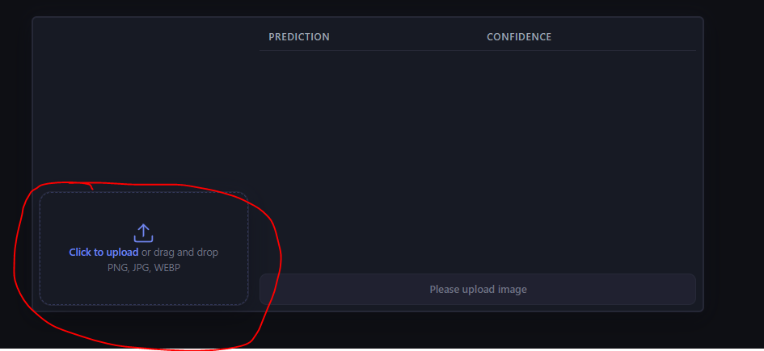
Figure 4.6 - Location of upload field.
- After image is uploaded, button on bottom right will become active. Press it to run inference. Refer to Fig. 4.7 for visual cue.
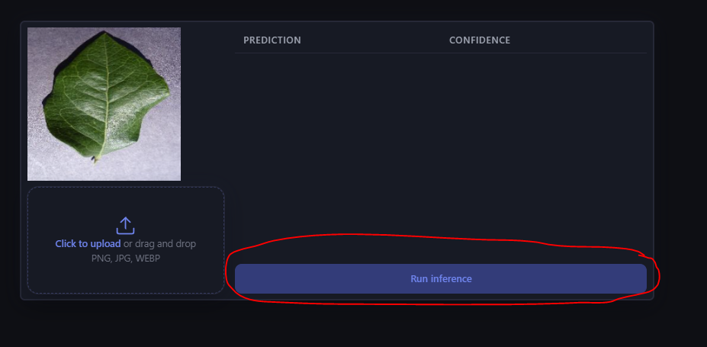
Figure 4.7 - View of “Run inference” after image was uploaded
- Wait for inference to end and observe results in table highlighted in Fig. 4.8.
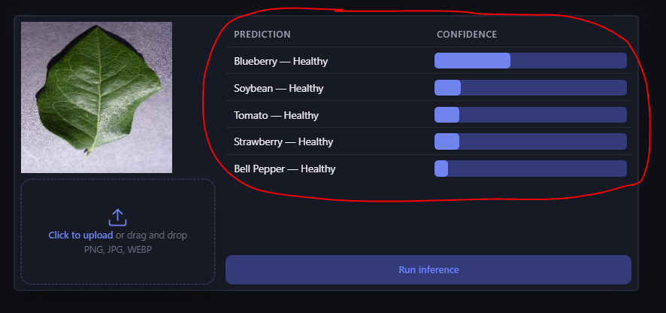
Figure 4.8 - Position of inference result table.

CONCLUSION
This work set out to design and develop an open-source, web-based system for automated plant disease classification using a convolutional neural network, with accessibility, computational efficiency, and ease of deployment as its primary design objectives. All five goals established in the Goals and Objectives chapter, open source availability, speed and efficiency, ease of use for end users, ease of use for developers, and web security, were addressed in the final system. The complete source code and model weights are publicly available at link provided in Appendix 1, ensuring that any individual or organization can deploy, use, and extend the system independently.
The system is built around a three-tier architecture comprising an Angular frontend, an ASP.NET Core backend, and a Rust-based inference engine compiled as a self-contained native DLL. This design ensures a clean separation of concerns across components while keeping the inference pipeline computationally lightweight and the deployment process straightforward. The frontend provides an intuitive, fully responsive interface accessible on both desktop and mobile devices, requiring no technical knowledge to operate.
The classification model is based on MobileNetV3-Large, trained via transfer learning on the PlantVillage dataset with TrivialAugmentWide augmentation and partial backbone fine-tuning of the last unfrozen block. The final model achieved 98.27% accuracy on the PlantVillage test set, demonstrating strong in-distribution classification performance consistent with results reported across the literature for models trained on this benchmark. Evaluation on the PlantDoc dataset, used as an independent out-of-distribution validation benchmark representative of real-world field conditions, yielded 4.17% accuracy, a result that, while low in absolute terms, is consistent with the fundamental domain gap challenge extensively documented in the literature review. It should further be noted that the PlantDoc dataset itself contains a non-negligible proportion of low-quality and irrelevant imagery, including presentation slides, which adversely affects evaluation reliability and likely contributes to the observed performance drop beyond what can be attributed to the model alone.
The domain gap between controlled laboratory training data and real-world field images remains the most significant open challenge in automated plant disease recognition, and this work is no exception to that trend. Future directions for improving real-world generalization include the adoption of more computationally capable backbone architectures such as EfficientNetV2, more rigorous dataset preprocessing including manual curation of PlantDoc, oversampling of underrepresented PlantVillage classes, and removal of overrepresented ones, and evaluation against additional real-world benchmarks beyond PlantDoc to obtain a more reliable estimate of out-of-distribution performance.
Overall, the system fulfils its stated purpose, providing a fast, accessible, open-source tool for plant disease classification that can be deployed and extended by anyone, and contributes a fully integrated, end-to-end implementation that bridges the gap between research-grade model training and practical web deployment.

SOURCES
- Plant disease classification in the wild using vision transformers and mixture of experts. URL: https://pmc.ncbi.nlm.nih.gov/articles/PMC12213485/
- A Comprehensive Survey on Transfer Learning. URL: https://arxiv.org/pdf/1911.02685
- TrivialAugment: Tuning-free Yet State-of-the-Art Data Augmentation. URL: https://arxiv.org/abs/2103.10158
- EfficientNet: Rethinking Model Scaling for Convolutional Neural Networks. URL: https://arxiv.org/abs/1905.11946
- EfficientNetV2: Smaller Models and Faster Training. URL: https://arxiv.org/pdf/2104.00298
- Using Deep Learning for Image-Based Plant Disease Detection. URL: https://pmc.ncbi.nlm.nih.gov/articles/PMC5032846/
- World Population Prospects 2024, UN. URL: https://population.un.org/wpp/
- Climate change, plant diseases and food security: an overview. URL: https://bsppjournals.onlinelibrary.wiley.com/doi/10.1111/j.1365-3059.2010.02411.x
- A meta-analysis of projected global food demand and population at risk of hunger for the period 2010-2050. URL: https://pubmed.ncbi.nlm.nih.gov/37117684/
- Climate change impacts on plant pathogens, food security and paths forward. URL: https://www.researchgate.net/publication/370466657_Climate_change_impacts_on_plant_pathogens_food_security_and_paths_forward
- An open access repository of images on plant health to enable the development of mobile disease diagnostics. URL: https://arxiv.org/abs/1511.08060
- A logical calculus of the ideas immanent in nervous activity. URL: https://link.springer.com/article/10.1007/BF02478259
- The perceptron: A probabilistic model for information storage and organization in the brain. URL: https://doi.org/10.1037/h0042519
- Perceptrons: An Introduction to Computational Geometry. URL: https://doi.org/10.7551/mitpress/11301.001.0001
- Gradient-Based Learning Applied to Document Recognition. URL: http://vision.stanford.edu/cs598_spring07/papers/Lecun98.pdf
- Backpropagation Applied to Handwritten Zip Code Recognition. URL: https://ieeexplore.ieee.org/document/6795724
- Very Deep Convolutional Networks for Large-Scale Image Recognition. URL: https://arxiv.org/abs/1409.1556
- Visualizing and Understanding Convolutional Networks. URL: https://arxiv.org/abs/1311.2901
- PlantDoc: A Dataset for Visual Plant Disease Detection. URL: https://arxiv.org/abs/1911.10317
- Uncovering bias in the PlantVillage dataset. URL: https://arxiv.org/abs/2206.04374
- Deep Residual Learning for Image Recognition. URL: https://arxiv.org/abs/1512.03385
- MobileNets: Efficient Convolutional Neural Networks for Mobile Vision Applications. URL: https://arxiv.org/abs/1704.04861
- Searching for MobileNetV3. URL: https://arxiv.org/abs/1905.02244

APPENDIX
- Source code - https://github.com/ThNeutral/diploma-project

